**A Project Report on**

**“An Integrated Lost & Found Management System for Efficient Item Tracking and Recovery”**

***Submitted in the partial fulfillment of the requirements for the award of the Degree of***

**Bachelor of Computer Application**

**Semester - VI (2025-26)**

**Submitted by**

**230801477 – Pipaliya Prince Alpeshbhai**

**230801508 – Ramani Het Kishorbhai**

**Guided by**

**Mr. Mehul Makwana**

**Submitted to**

**Faculty of Science**

**Department of Computer Science**

**Atmiya University**

**Replace the sample certificate with your original certificate.**



**DECLARATION**

I hereby declare that the project report titled “**An Integrated Lost & Found Management System for Efficient Item Tracking and Recovery**” is my original work and has been completed under the guidance of Mr. Mehul Makwana. This project is submitted in the partial fulfillment of the requirements for the award of the Degree of Bachelor of Computer Application, Semester – VI (2025–26) under the Faculty of Science, Department of Computer Science, Atmiya University, Rajkot, Gujarat-India.

I also declare that this work has not been submitted to any other university or institution for any degree, diploma, or certificate.

Name of Student: Pipaliya Prince Alpeshbhai

Enrollment No.: 230801477

Signature:

Date:

**ACKNOWLEDGEMENT**

I express my deep sense of gratitude to the following respected authorities of Atmiya University for their constant support, guidance, and encouragement throughout the completion of this project.

I am sincerely thankful to **P. P. Tyagvallabh Swami** (President, Atmiya University) for providing an excellent educational environment and continuous encouragement toward academic excellence.

I extend my gratitude to **Dr. D. D. Vyas** (Registrar, Atmiya University) for ensuring smooth academic processes and administrative support that contributed to the successful completion of this project.

I am grateful to **Er. R. S. Tank** (Dean, Faculty of Science) for his valuable support, motivation, and guidance throughout the duration of the program.

My heartfelt thanks to **Dr. D. P. Gohel** (Head, Department of Computer Science) for providing necessary facilities, timely support, and continuous encouragement during the project work.

I would like to express my special appreciation and sincere thanks to my project guide **Mr. Mehul Makwana**, whose expert guidance, patience, and valuable suggestions helped me complete this project successfully.

I am also thankful to all the faculty members of the Department of Computer Science for their support, feedback, and academic insights throughout the course.

Finally, I gratefully acknowledge the constant support, motivation, and encouragement of my family and friends, without which this project would not have been completed.

**ABSTRACT**

In today’s fast-paced world, losing personal belongings in public spaces such as universities, airports, or large organizations is a common occurrence. The traditional method of recovering lost items often involves manual inquiries, physical notice boards, or visiting security offices, which is time-consuming and inefficient. To address this issue, this project presents a **Web-Based Lost and Found System**, a centralized digital platform designed to bridge the gap between people who have lost items and those who have found them.

The system is built using the **MERN Stack (MongoDB, Express.js, React.js, Node.js)**, ensuring a robust, scalable, and responsive application. Key features include user authentication, real-time item posting with image uploads, categorized searching, and a secure communication channel between users using **Socket.io**. The platform also includes an administrative dashboard for monitoring activities and managing users to prevent misuse.

By digitizing the lost and found process, this web application significantly re duces the time taken to recover items, increases the probability of retrieval through visual identification, and provides a secure environment for exchanging contact information. The successful implementation of this system demonstrates the practical application of modern web technologies in solving real-world utility problems.

**Table of Content**

|  |  |  |
| --- | --- | --- |
| **SN** | **Chapter** | **Page No.** |
|  | Certificate | I |
|  | Declaration | II |
|  | Acknowledgment | III |
|  | Abstract | IV |
|  | Table of Contents | V |
| 1 | Introduction | 1 |
| 2 | Problem Definition | 2 |
| 3 | Objectives of the Study | 3 |
| 4 | System Analysis | 4 |
| 5 | System Design | 5 |
|  | 5.1 Data Flow Diagrams (DFD) |  |
|  | 5.2 UML Diagrams |  |
|  | 5.3 ER Diagram |  |
| 6 | Implementation | 6 |
| 7 | Testing | 7 |
| 8 | Output Screenshots | 8 |
| 9 | Conclusion | 9 |
| 10 | Future Scope | 10 |
| 11 | Bibliography / References | 11 |
| 12 | Appendix | 12 |
|  |  |  |
|  |  |  |
|  |  |  |
|  |  |  |
|  |  |  |
|  |  |  |

**Chapter 1 – INTRODUCTION**

* + 1. **Overview**

The advent of the internet and web technologies has revolutionized how we handle daily tasks, from communication to commerce. However, certain local community challenges, such as the management of lost and found items, often rely on outdated, manual processes. This project introduces a **Lost and Found Web Application**, a digital solution aimed at simplifying the recovery of lost personal property within a community or institution.

This application provides a user-friendly interface where individuals can report lost items or report found items. By leveraging the power of a centralized database and internet connectivity, the system ensures that information about lost items reaches a wide audience instantly, unlike physical notice boards which have limited visibility.

* 1. **Purpose and Scope**

The primary purpose of this project is to automate the manual “Lost and Found” department found in many organizations. **\* Purpose:** To create a reliable, online platform where users can post details about lost or found items, including descriptions, categories, and photographs, to facilitate easy identification and recovery. **\* Scope:** The scope of this system extends to any organization or community (like a university campus, corporate office, or residential society) that requires a dedicated portal for managing lost property. It handles user registration, secure login, item posting (with images), searching/filtering items, and administrative oversight. It does not handle the physical storage or logistics of the items but serves as the information bridge.

* 1. **Background Information**

Historically, lost and found systems have been paper-based. A person finding an item would hand it over to a security desk, where details would be entered into a physical logbook. A person looking for an item would have to physically visit the desk and hope the item was turned in.

Technologically, early attempts to digitize this involved simple static websites or basic forms that emailed an administrator. Modern web development frame works like the **MERN stack** allow for dynamic, real-time interaction. This project builds upon these advancements by integrating **Socket.io** for real-time capabilities and **Cloudinary/Multer** for efficient image handling, making the process seamless and immediate.

**Chapter 2 – PROBLEM DEFINITION**

1. **The Core Problem**

In large institutions such as universities or corporate campuses, thousands of people move around daily. Inevitably, personal items like keys, wallets, electronics, and documents are misplaced. The core problem is the **lack of a centralized, accessible, and efficient mechanism** to report and track these items.

1. **Existing Challenges**

The current manual or semi-digital systems suffer from several limitations: **1.** **Limited Accessibility:** Physical logbooks are only accessible during office hours and require physical presence. **2.** **Lack of Visuals:** A text description in a logbook (“Black bag”) is often insufficient to identify an item uniquely compared to a digital photo. **3. Delayed Communication:** There is a significant time lag between an item being found and the owner becoming aware of it**. 4. Inefficiency:** Security personnel spend valuable time managing these inquiries instead of focusing on security duties. **5. Low Recovery Rates:** Due to the friction in the process, many lost items are never claimed, and many found items settle in storage rooms indefinitely.

1. **Need for a Technical Solution**

A technical solution is required to decouple the reporting process from physical constraints. A web-based system allows reporting 24/7 from any location. It enables the use of images for quick identification and search filters (e.g., “Electronics”, “Date Lost”) to narrow down inquiries instantly. This project addresses the need for a **smart, self-service platform** that empowers users to help themselves and each other, reducing administrative burden and increasing recovery rates.

**Chapter 3 – OBJECTIVES OF THE STUDY**

The main objective of this project is to design and develop **a Lost and Found System** that efficiently manages the reporting and recovery of lost items. The specific objectives are as follows:

* **To Develop a Centralized Repository:** Create a unified database where all lost and found reports are stored and easily accessible.
* **To Enhance Accessibility:** ensure the platform is accessible via standard web browsers, allowing users to report items from computers or mobile devices.
* **To Improve Identification:** Implement image upload functionality to allow visual verification of items, significantly reducing false claims and confusion.
* **To Facilitate Secure Communication:** Provide a secure way for the finder and the owner to communicate without necessarily revealing sensitive personal contact details publicly.
* **To Simplify Administration:** Provide an admin dashboard to monitor posts, remove spam or inappropriate content, and view analytics on lost/found trends.
* **To Reduce Recovery Time:** Automate the matching process through search and filtering to minimize the time an item stays in the “lost” state.

**Chapter 4 – SYSTEM ANALYSIS**

1. **Existing System**

The existing system in most institutions is primarily manual. * **Working Method:** A person finds an item and drops it at a designated “Lost & Found” box or security desk. The security guard writes the details in a register. The owner must physically visit different desks to ask if their item has been found. * Requires physical presence at specific locations. * **No Searchability:** One cannot “search” a physical logbook efficiently; they must read through pages of handwriting. * **Data Redundancy:** Details might be recorded inconsistently across different entry gates or departments. * **Risks:** Items can be stolen if not logged immediately. Logs can be lost or damaged. There is no privacy for the claimant’s contact details in a public register.

1. **Proposed System**

The proposed system is a **Web-Based Applica**tion accessible via any internet enabled device. * **System Workflow**: Users register and log in. A “Finder” posts details of an item with a photo. A “Loser” searches the database using key words. If a match is found, they can connect via the platform. * **Advantages: * 24/7 Availability:** Operate round the clock. * **Global Reach:** Within the intranet or internet, anyone can access it. * **Visual Aid:** Photographs make identification 100% easier. * **User Management:** Authentication pre vents anonymous spamming. * **Solution:** It solves the problem of “information asymmetry” where the finder has the item and the loser wants it, but they have no medium to connect. This platform provides that medium.

1. **Feasibility Study**

A detailed feasibility study was conducted to determine the viability of the project.

1. **Technical Feasibility**

The system is built on the **MERN Stack** (MongoDB, Express, React, Node.js). These are open-source, mature technologies with vast community support. The development team represents proficiency in JavaScript, making this tech stack highly feasible. The application is lightweight and can run on standard cloud servers or local institutional servers. * **Conclusion:** Technically Feasibility is **High.**

1. **Economic Feasibility**

The project uses open-source software (Node.js, MongoDB Community Edition, React), meaning there are **no licensing costs.** The only potential cost is hosting (e.g., AWS, Heroku, or Render), which is minimal for a university-scale project. * **Conclusion:** Since development costs are time-based and software costs are zero, the project is **Economically Viable.**

1. **Operational Feasibility**

The interface is designed to be intuitive, resembling popular social media feeds. Users familiar with basic internet browsing will find it easy to use. No special training is required for the general user. Admins require a simple orientation to the dashboard. * **Conclusion:** The system is **Operationally Feasible.**

1. **Requirement Specification**

**Hardware Requirements**

**Component** :- Processor

RAM Storage Internet

Display

**Minimum Requirement** :- Intel Core i3 or equivalent 4 GB 256 GB HDD/SSD 1 Mbps stable connection 1366 x 768 Resolution

**Recommended Requirement** :- Intel Core i5 or higher 8 GB or higher 512 GB SSD Broadband / 4G / 5G 1920 x 1080 Full HD

**Software Requirement Component :-** Operating System, Backend Framework, Frontend Library,Database, Code Editor, Browser, Version Control

**Specification** :- Windows 10/11, macOS, or Linux, Node.js (v18+) with Express.js, React.js (v18+),MongoDB (Cloud Atlas or Local v6.0), Visual Studio Code (VS Code), Google Chrome,Firefox, or Edge Git & GitHub

**Chapter 5 – SYSTEM DESIGN**

System design bridges the gap between requirements and implementation. We use Mermaid diagrams to visualize the architecture.

1. **Data Flow Diagram (DFD)**

The DFD Level 0 illustrates the high-level interaction between the User, Admin, and the System.

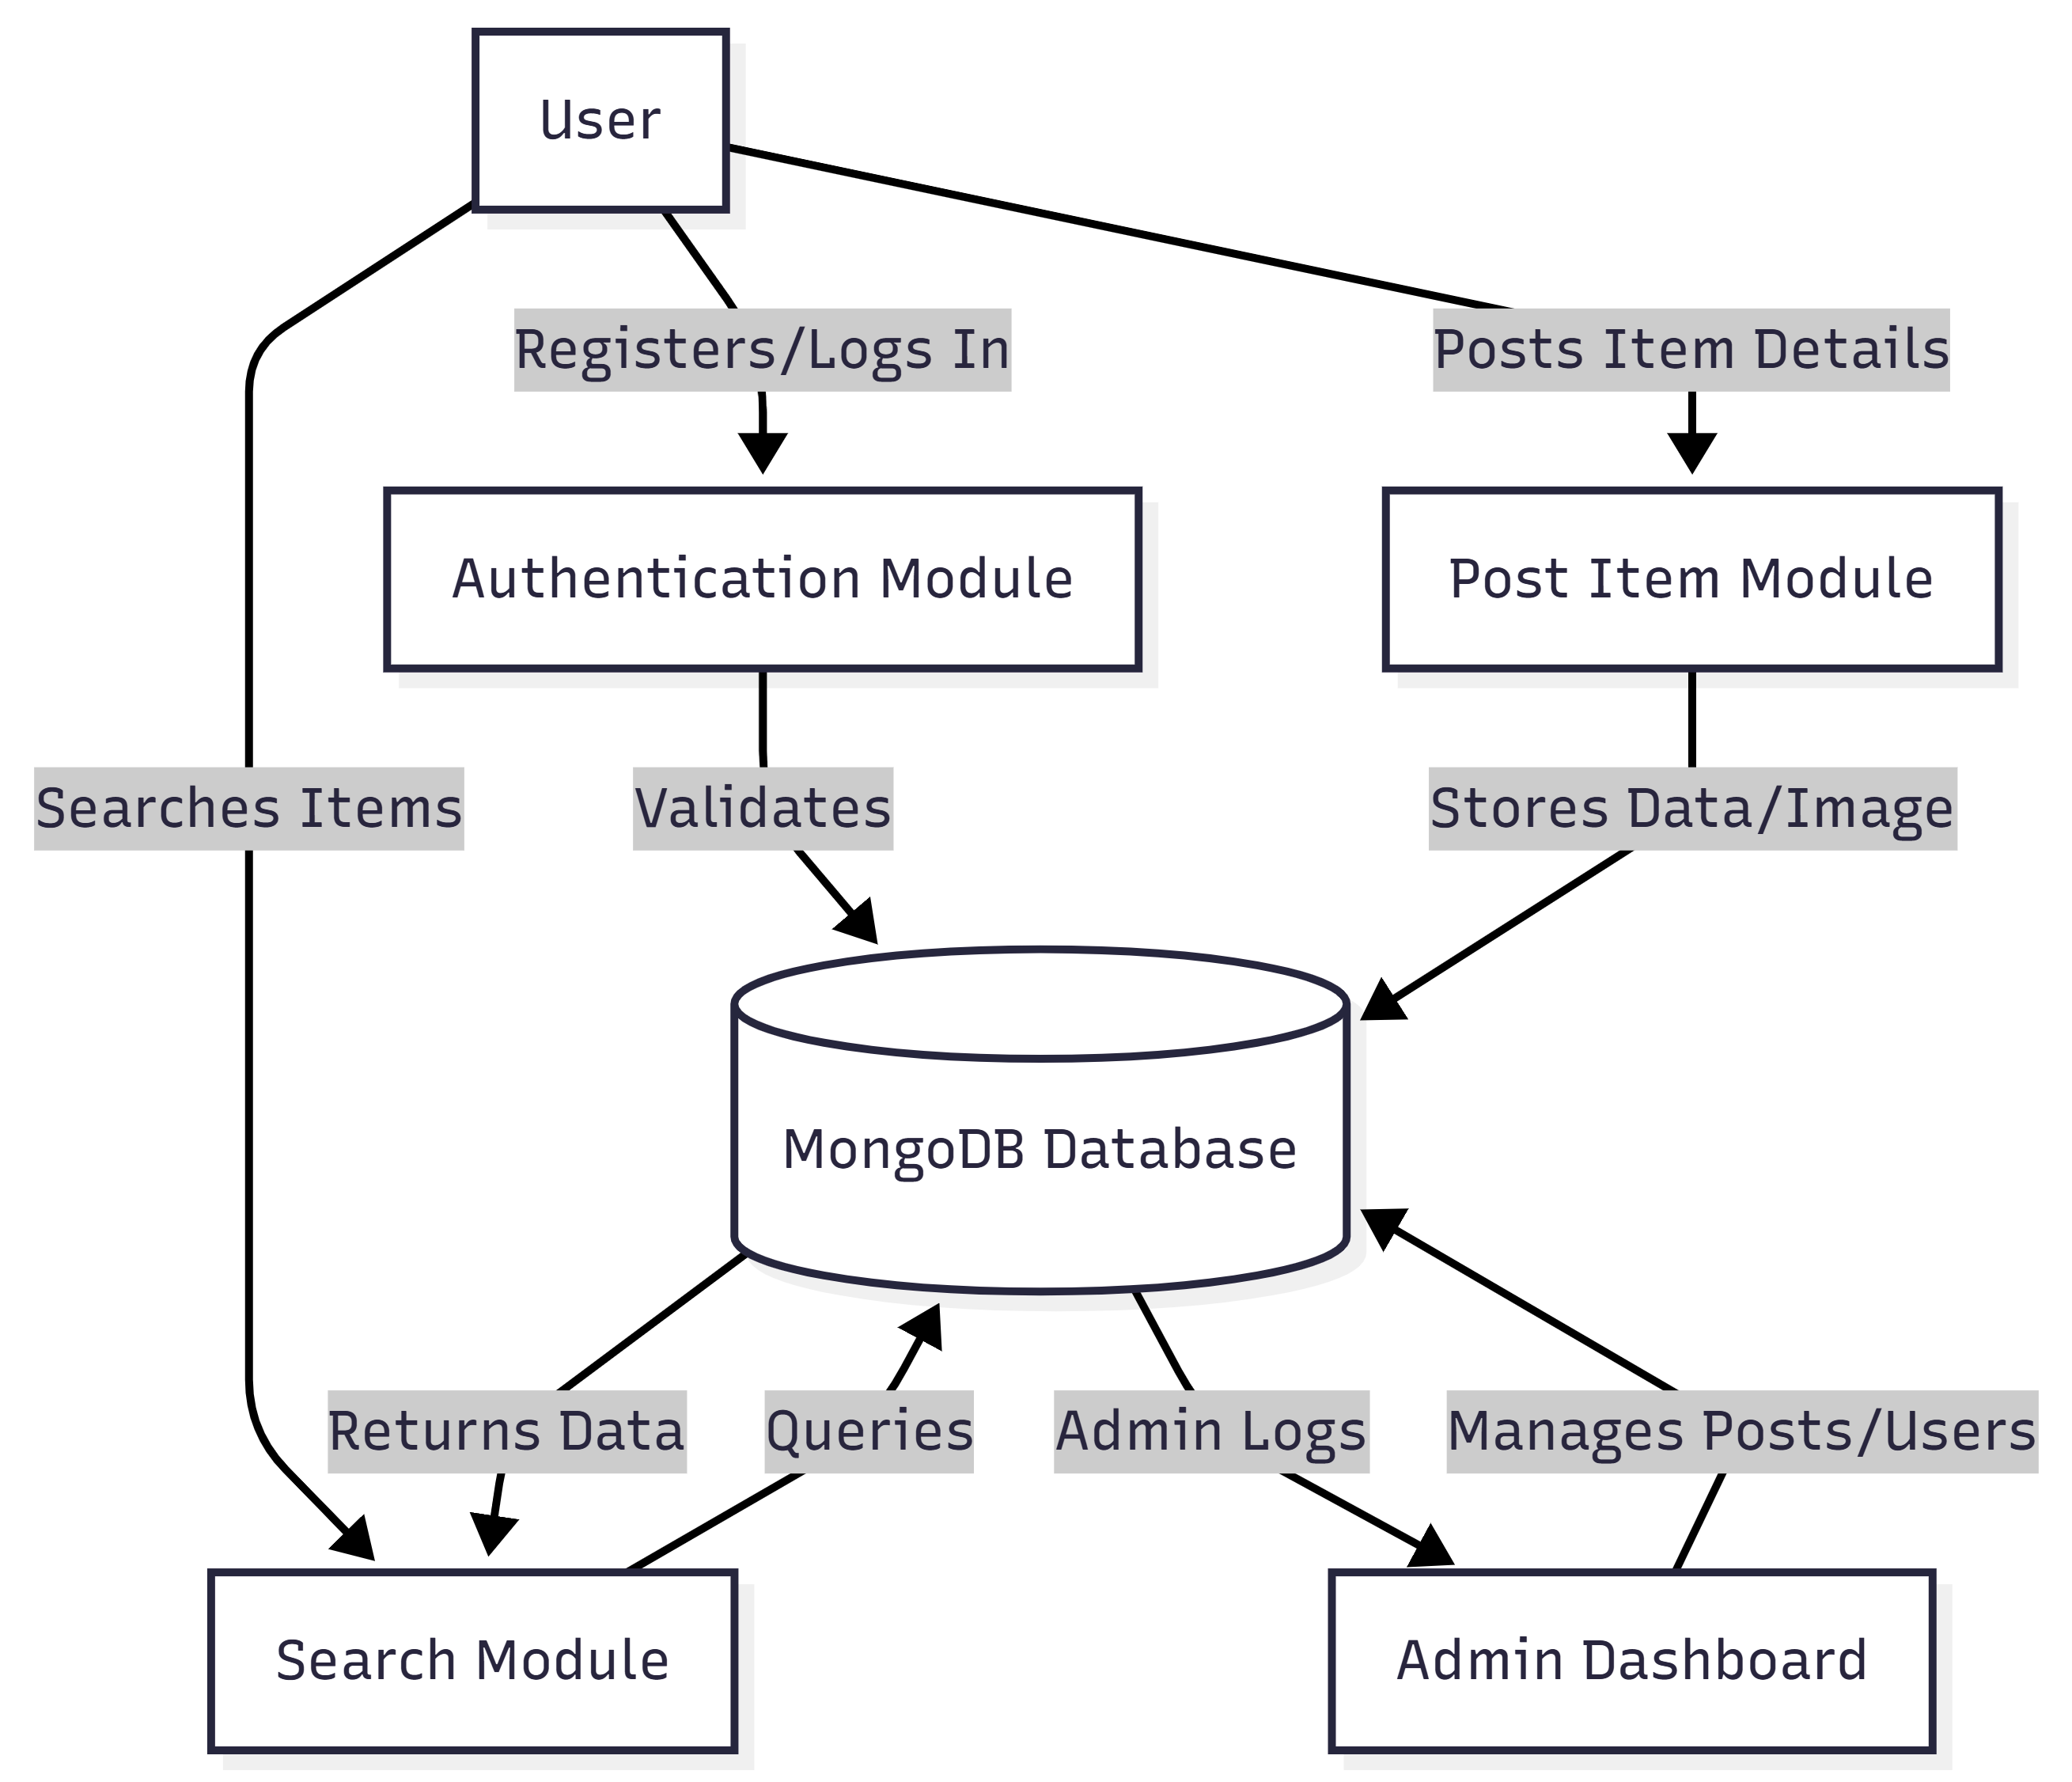

1. **Use Case Diagram**

This diagram identifies the primary actors (User, Admin) and their interactions with the system functionalities.

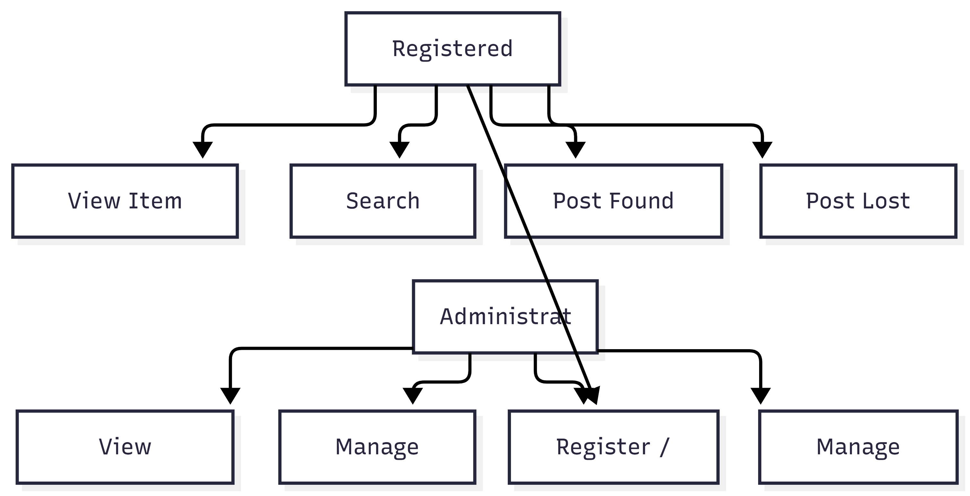

1. **Class Diagram**

The Class Diagram represents the static structure of the system, showing the classes, their attributes, and relationships.

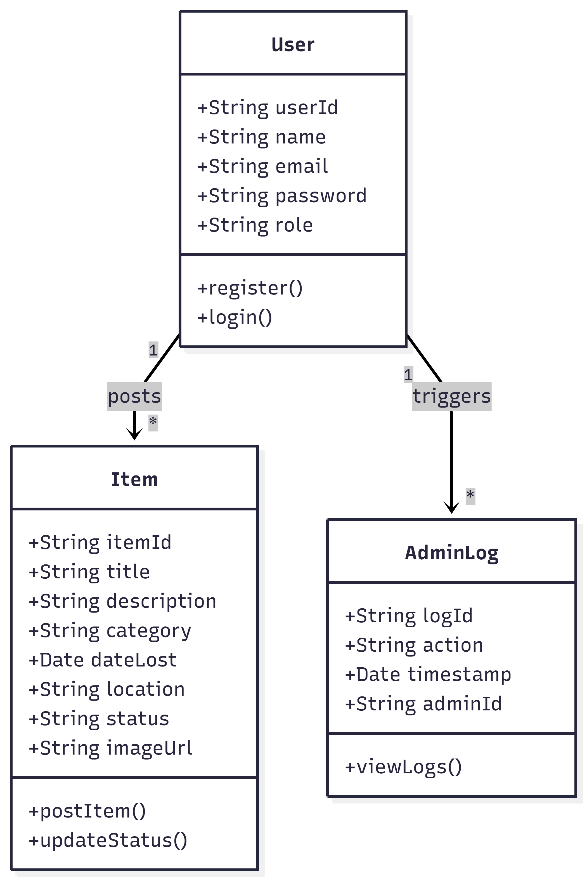

1. **Activity Diagram**

This diagram flows through the process of reporting a found item.

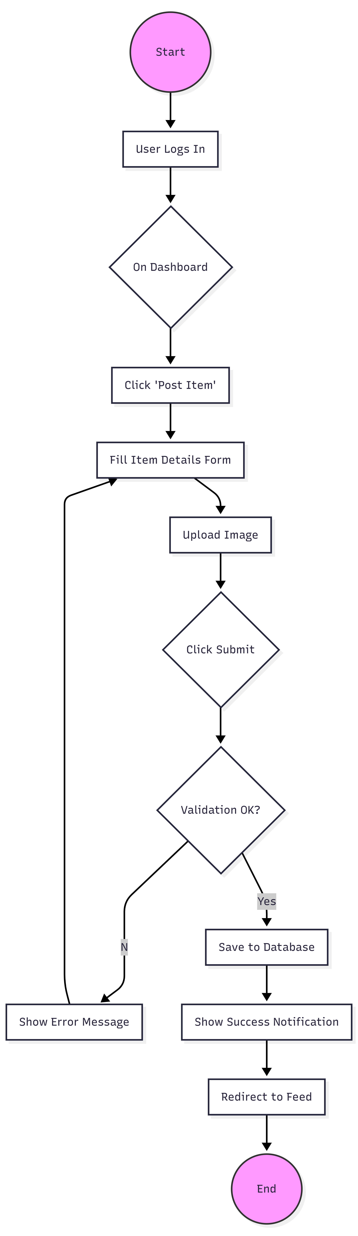

1. **Entity Relationship (ER) Diagram**

The ER Diagram models the database schema and relationships between entities.

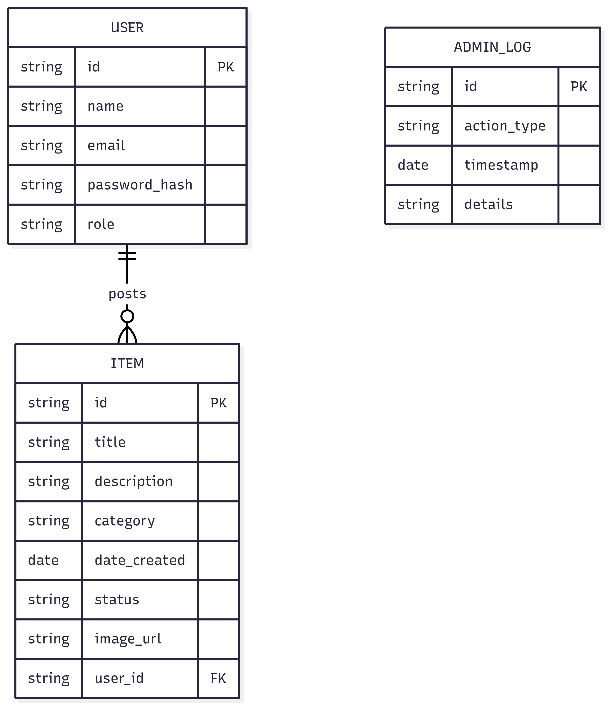

1. **System Architecture Diagram**

A high-level view of the MERN stack architecture deployed in this project.

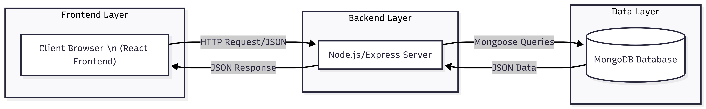

**Chapter 6 – IMPLEMENTATION**

The implementation process involves translating the design specifications into a working system. This project is implemented using the MERN stack, divided into frontend and backend modules.

1. **Backend Module**

The backend is the backbone of the application, managing data processing, business logic, and database interactions. * **Functionality:** Created RESTful APIs for creating users, posting items, and fetching data. * **Technologies Used:** * **Node.js:** As the runtime environment. * **Express.js:** For routing and middleware (CORS, body-parser). * **Mongoose:** For modeling MongoDB data structures (User, Item schemas). * **JSON Web Tokens (JWT)**: Implemented in auth.js to securely authenticate users and maintain sessions. * **Multer:** Used to handle multipart/form-data for uploading images of lost/found items to local storage or cloud.

1. **Frontend Module**

The frontend is the visual interface that users interact with. * **Functionality:** Provides forms for reporting items, a dashboard for viewing feeds, and pro file management. * **Technologies Used:** * **React.js:** Functional components (Hooks like useState, useEffect) manage the UI state. * **React Router:** Enables single-page application (SPA) navigation between Login, Register, Home, and Dashboard. * **Axios:** Handles asynchronous HTTP requests to the backend APIs. * **Tailwind CSS:** Utility-first CSS framework for rapid, responsive UI design.

1. **Key Component Description**

**6.3.1 User Authentication Module**

This module handles user registration and login. * **Process:** When a user registers, their password is hashed using bcryptjs before being stored in MongoDB. On login, the password is validated, and a JWT token is issued. * **Input:** Name, Email, Password, Phone Number. * **Output:** Authentication Token and User Profile.

**6.3.2 Item Posting Module**

Allows authenticated users to report a lost or found item. * **Process:** The user f ills a form (PostItem.js) with details like title, category, date, and uploads an image. The frontend sends this data to the /api/items endpoint. * **Input:** Item Title, Description, Location, Date, Image File. * **Output:** New item record in database and updated Home Feed.

**6.3.3 Admin Dashboard Module**

A restricted area for administrators to oversee the platform. * **Process:** The system checks the user role. If role === 'admin', access is granted to Admin.js. * **Functionality:** View all users, delete spam posts, and view system logs (AdminLogs.js).

**6.4 Coding Standards**

**• Modular Code:** Separated concerns into controllers, models, and routes.

**• Naming Conventions:** CamelCase for variables/functions (e.g., postItem), PascalCase for React components (e.g., ItemDetail).

**• Error Handling:** comprehensive try-catch blocks in async functions to prevent server crashes.

**Chapter 7 – TESTING**

Testing ensures the application functions as intended and is free of critical bugs. We employed several testing strategies.

1. **Types of Testing**

* **Unit Testing:** Individual components (like the “Post Item” button or “Login” form) were tested in isolation to ensure they render correctly and handle user input.
* **Integration Testing:** Tested the interaction between the React frontend and Node.js backend. For example, ensuring that clicking “Submit” on the front end actually creates a document in MongoDB.
* **System Testing:** The entire application flow was tested from start to finish: Registering -> Logging in -> Posting an Item -> Searching for it.
* **Acceptance Testing:** Verified that the requirements from Chapter 4 (functionality, usability) were met.

1. **Test Cases**

|  |  |  |  |  |  |
| --- | --- | --- | --- | --- | --- |
| **Test Case ID** | **Test Description** | **Input Data** | **Expected Result** | **Actual Result** | **Status** |
| TC_01 | User Registration | Valid Email & Password | User created, redirect to Login | User created, redirect to Login | **Pass** |
| TC_02 | Login Validation | Unregistered Email | Error: “User not found” | Error: “User not found” | **Pass** |
| TC_03 | Post Item without Image | Text details only | Error: “Image required” | Error: “Image required” | **Pass** |
| TC_04 | Upload Large Image | Image > 5MB | Error: “File too large” | Error: “File too large” | **Pass** |
| TC_05 | View Item Details | Click on Item Card | Open Detail View with data | Opens Detail View with data | **Pass** |
| TC_06 | Search Functionality | Keyword “Wallet” | Show items with “Wallet” intitle | Shows filtered list | **Pass** |
| TC_07 | Admin Access | User credentials | Access Denied | Access Denied | **Pass** |
| TC_08 | Admin Access | Admin credentials | Open Admin Dashboard | Opens Admin Dashboard | **Pass** |

**Chapter 8 – OUTPUT SCREENSHOTS**

**8.1 Homepage (Landing Page)**

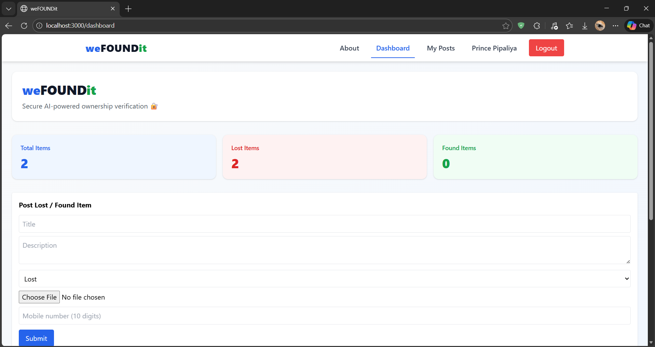

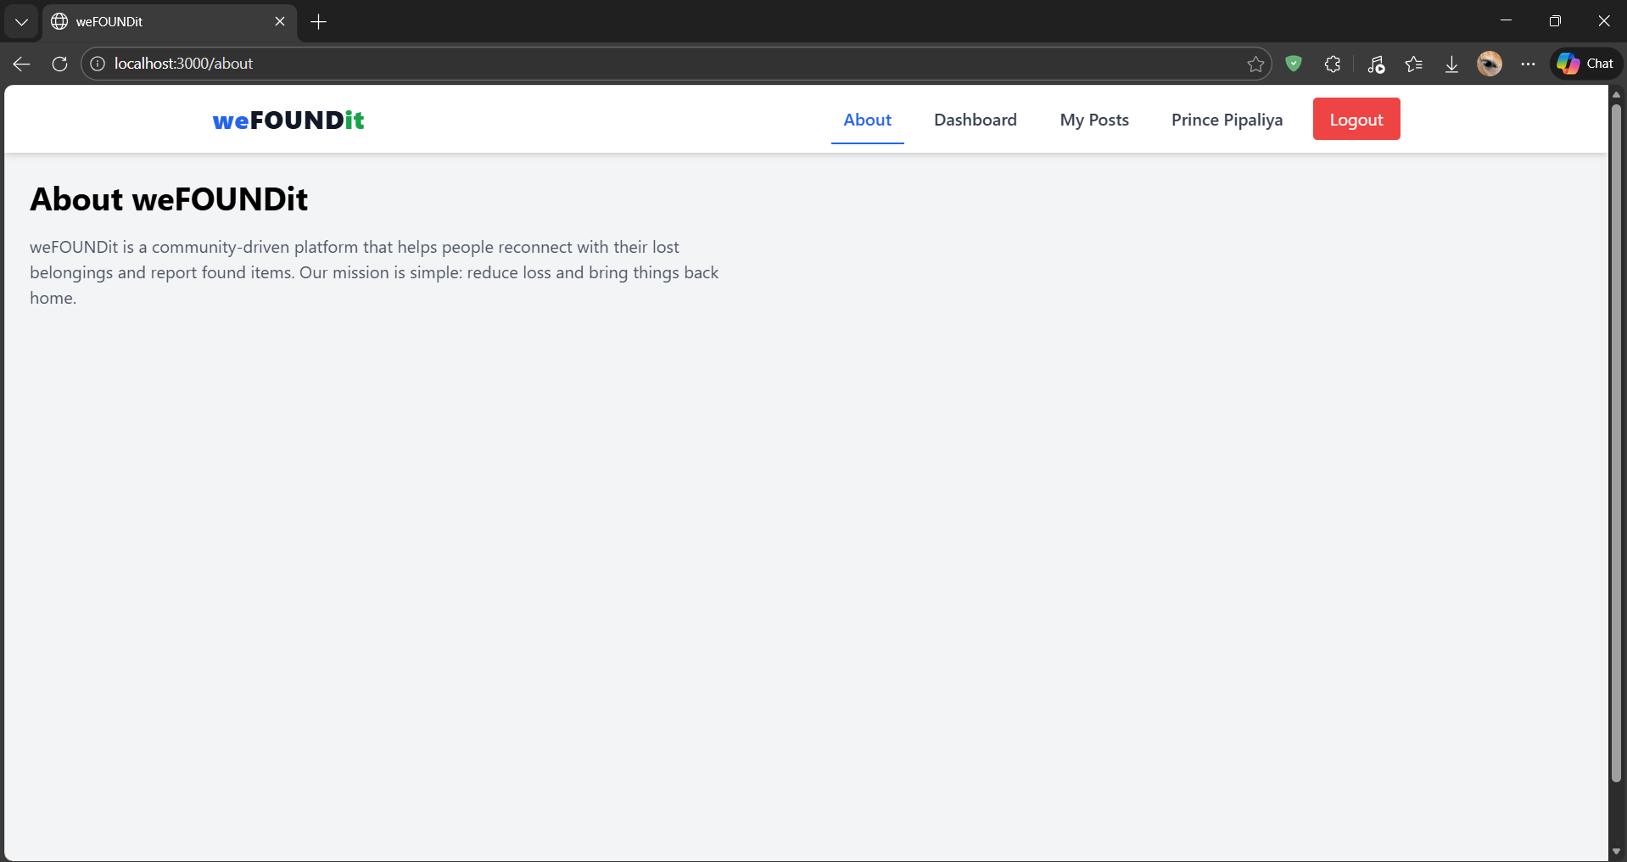

**8.2 User Registration**

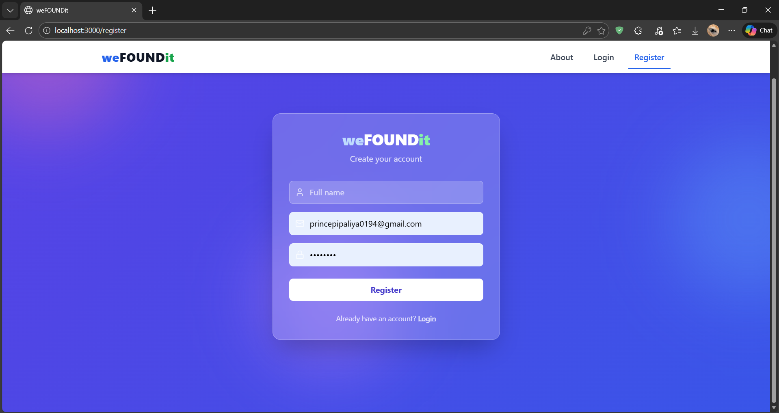

**8.3 Login Page**

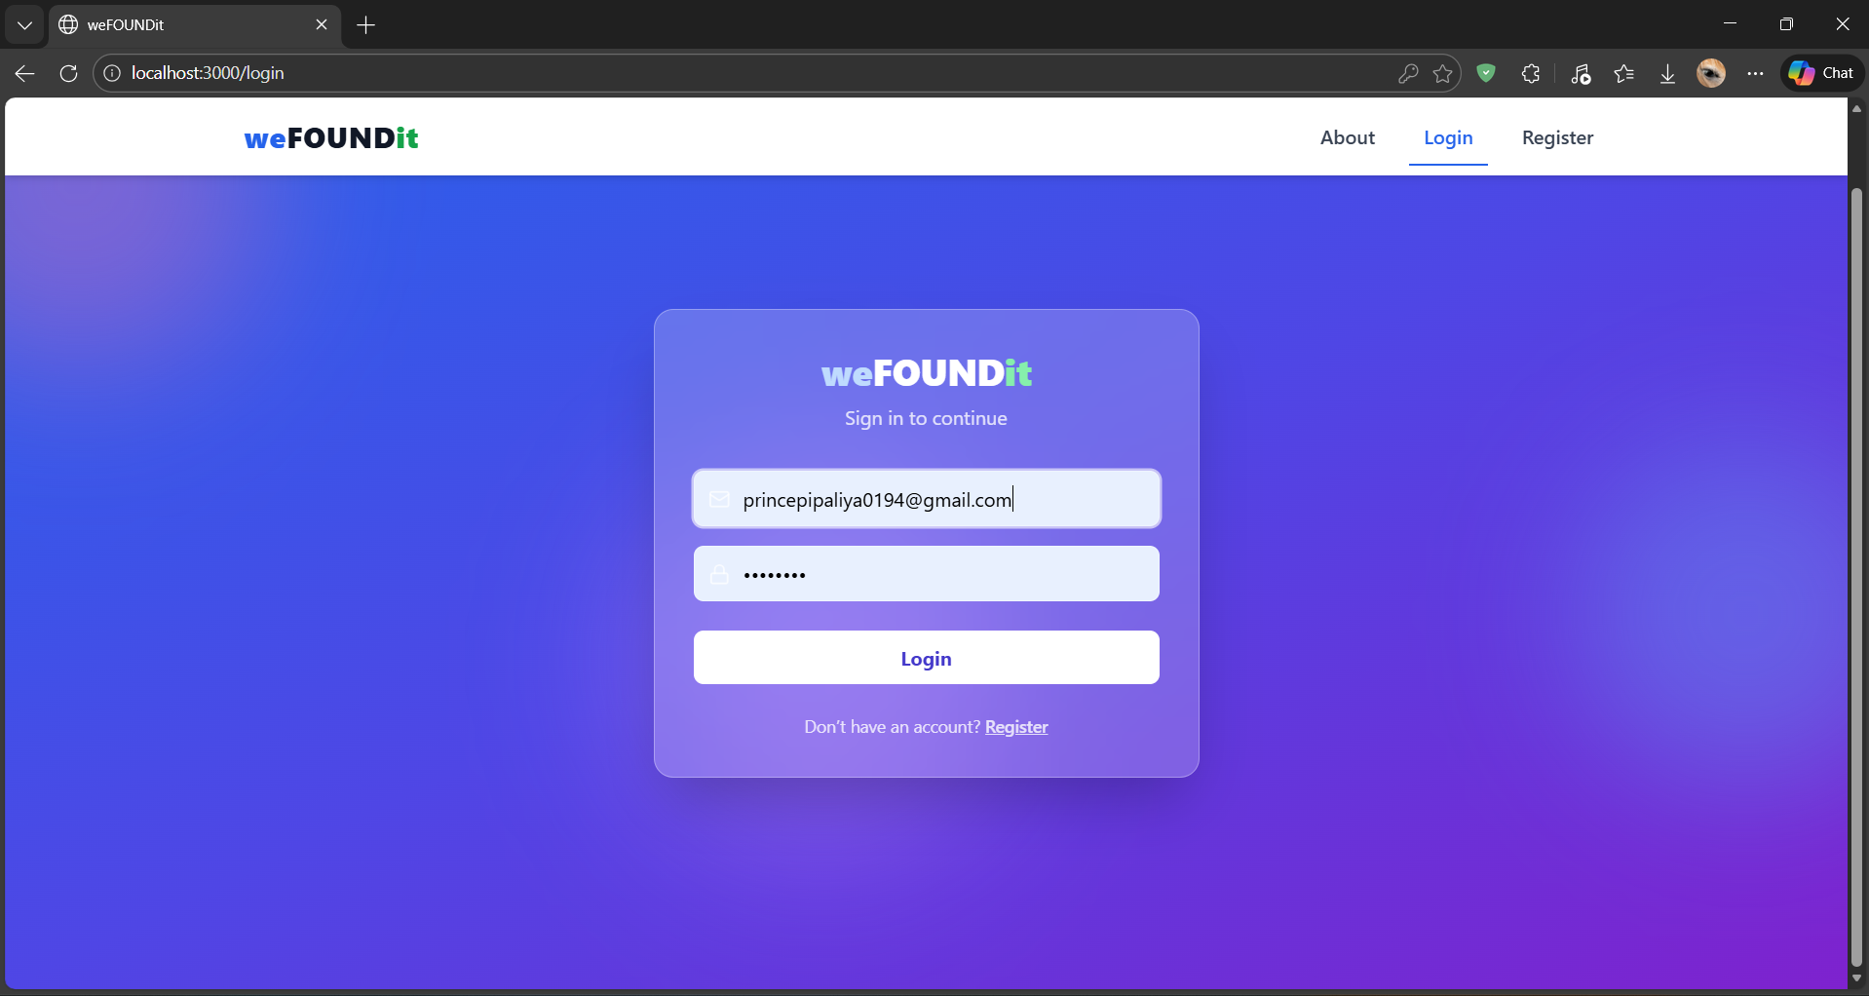

**8.4 Post Item Interface**



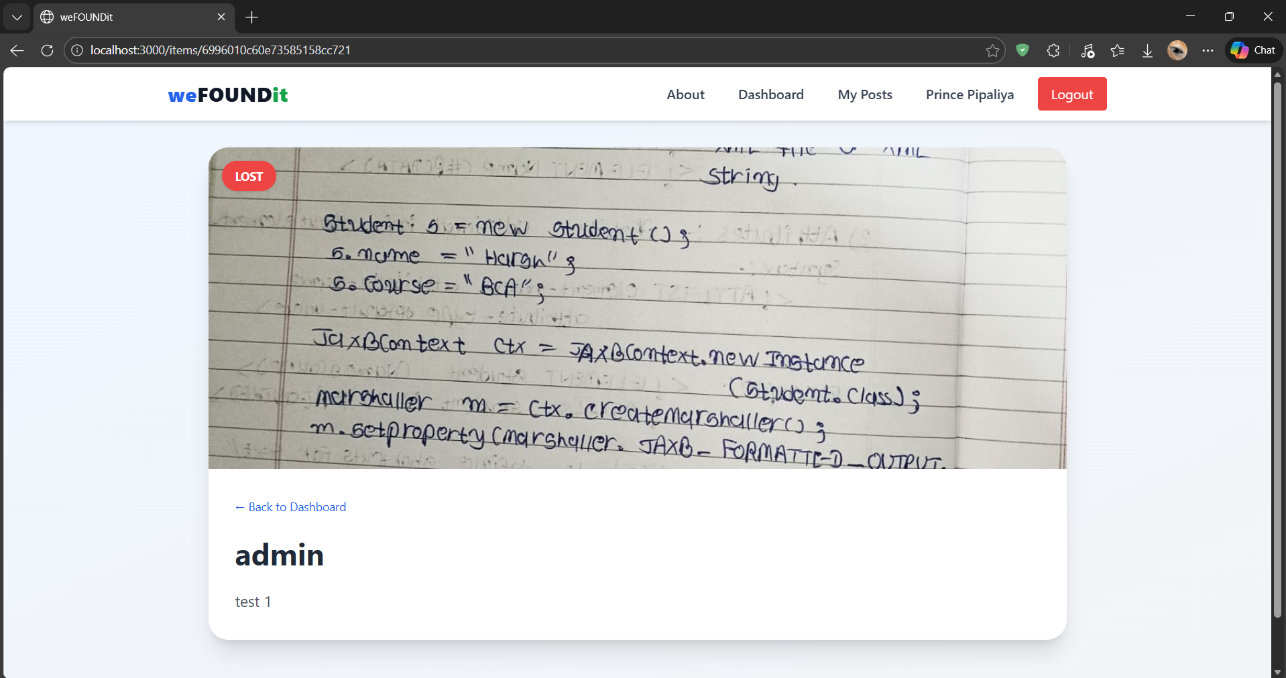

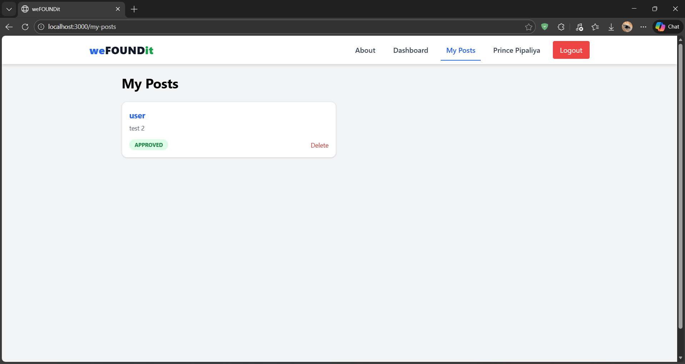

**8.5 Admin Dashboard**

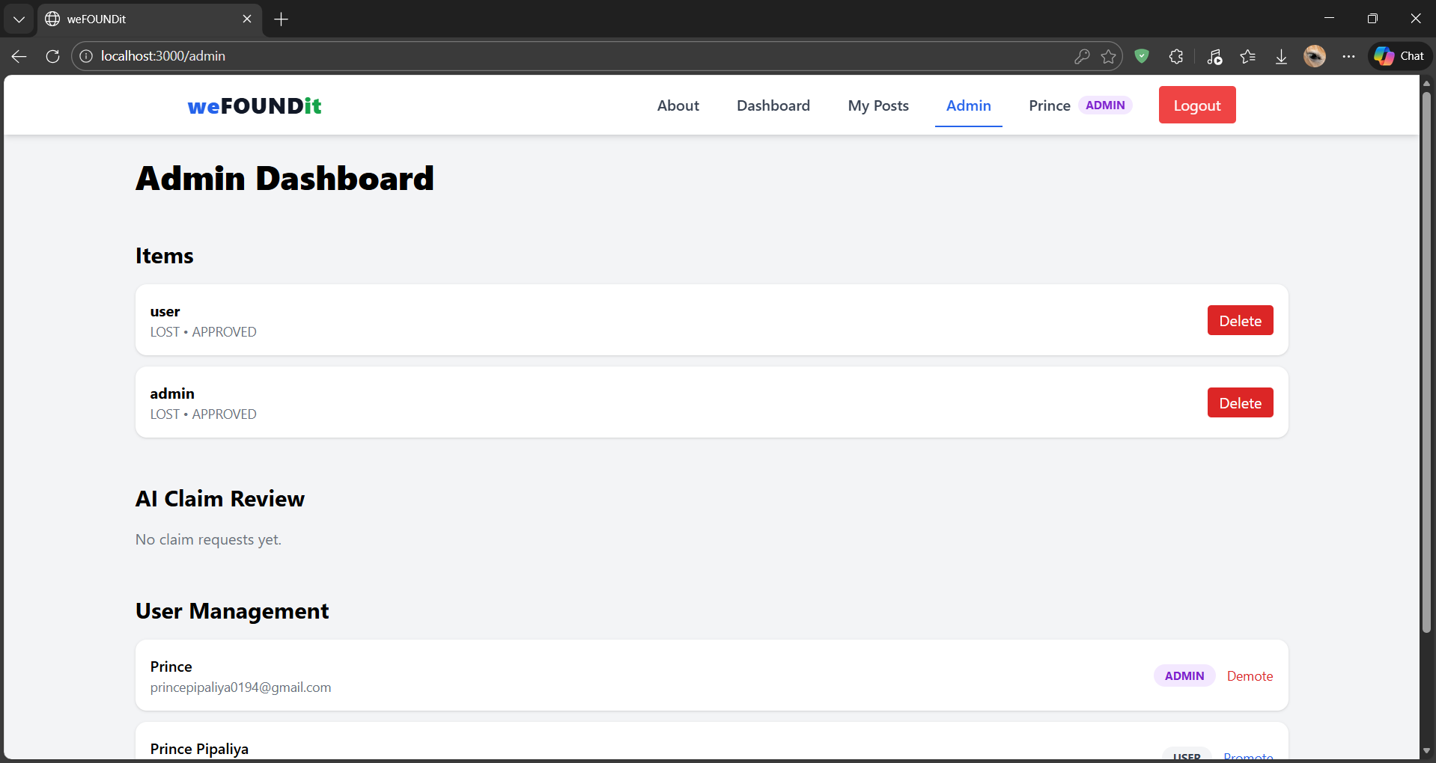

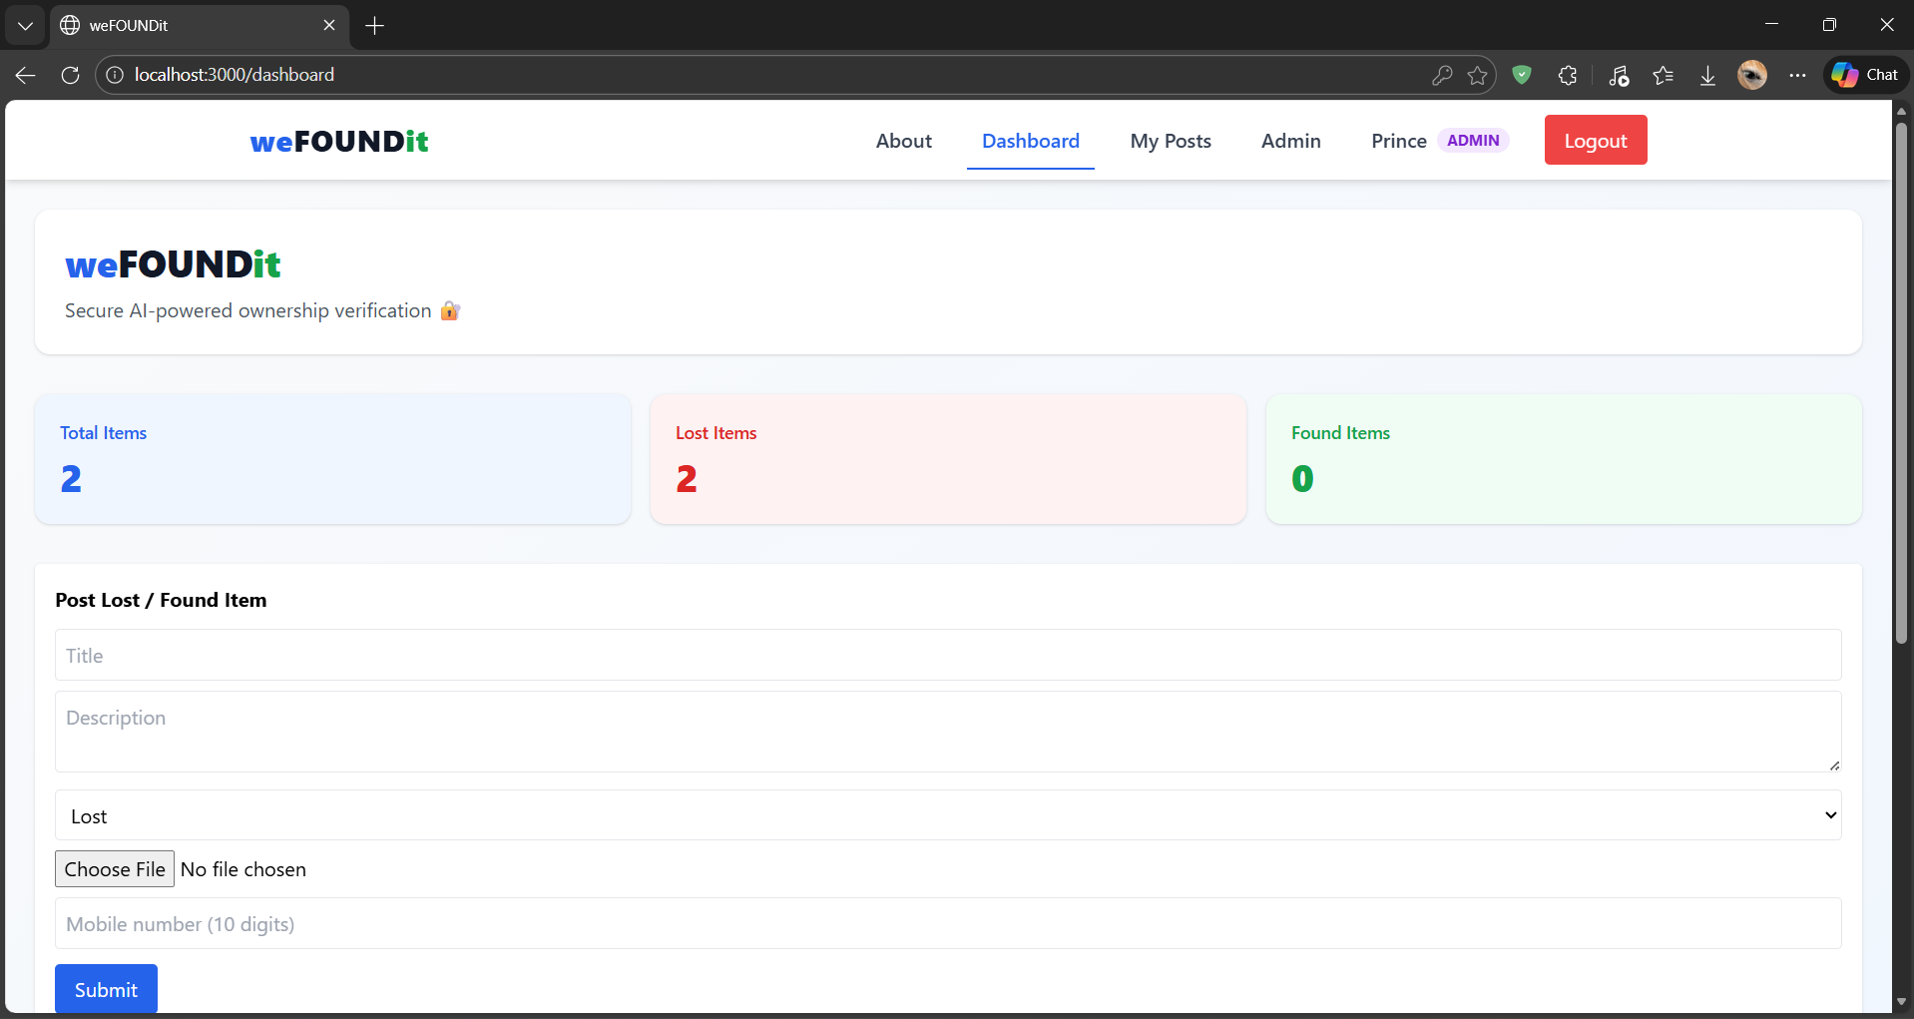

**Chapter 9 – CONCLUSION**

The **Lost and Found Web** **Application** successfully addresses the common problem of misplaced belongings in large communities. By replacing the traditional manual logbook with a **digital, centralized, and image-based system**, we have significantly improved the efficiency of item recovery.

The project met all its primary objectives: 1. **Accessibility**: Users can report items from anywhere, anytime. 2. **Efficiency**: Visual identification through image uploads eliminates ambiguity. 3. **Scalability**: The MERN stack architecture allows the system to handle increasing data loads without performance degradation.

While challenges such as user adoption and verifying ownership claims remain, the system provides a robust foundation for a modern community utility tool. It stands as a testament to how simple web technologies can solve persistent real-world inconveniences.

**Chapter 10 – FUTURE SCOPE**

The current system serves as a solid MVP (Minimum Viable Product), but there is significant room for enhancement:

* **AI Image Recognition:** integrating an AI model (like Google Vision API) to automatically tag uploaded images (e.g., detect “Black Wallet”) and auto-match them with reported lost items.
* **Mobile Application:** Developing a native React Native mobile app to allow push notifications when a matching item is found.
* **Geolocation Integration:** Integration with Google Maps to pin the exact location where an item was lost or found.
* **Reward System:** Implementing a “Karma Points” or small reward system to encourage people to return found items.
* **SSO Integration:** For universities, integrating with the institution’s existing ID system (LDAP/SSO) for seamless login.

**Chapter 11 – BIBLIOGRAPHY / REFERENCES**

**Books**

1. Banks, A. & Porcello, E. (2017). Learning React: Functional Web Development with React and Redux. O’Reilly Media.
2. Holmes, S. (2019). Getting MEAN with Mongo, Express, Angular, and Node. Manning Publications.

**Websites & Documentation**

1. React Documentation: https://react.dev/- Accessed Jan 2026.
2. Node.js Documentation: https://nodejs.org/en/docs/- Accessed Jan 2026.
3. MongoDB Manual: https://www.mongodb.com/docs/manual/- Accessed Jan 2026.
4. Express.js Routing: [https://expressjs.com/en/guide/routing.html- Accessed Jan 2026](https://expressjs.com/en/guide/routing.html-%20Accessed%20Jan%202026).
5. Socket.io: https://socket.io/docs/v4/- Accessed Jan 2026.

**Chapter 12 – APPENDIX**

1. **Sample Code Snippet (Backend Route)**

/* routes/items.js- Handling Item Posting */

router.post('/', auth, upload.single('image'), async (req, res) => {

try {

const newItem = new Item({

title: req.body.title,

description: req.body.description,

user: req.user.id,

imageUrl: req.file.path

});

const item = await newItem.save();

res.json(item);

} catch (err) {

console.error(err.message);

res.status(500).send('Server Error');

}

});

1. **Sample Data Structure (JSON)**

{

"_id": "60d5ec49f1b2c8200000001",

"title": "Blue Dell Laptop",

"category": "Electronics",

"type": "Lost",

"location": "Library 2nd Floor",

"status": "Open",

"user": {

"name": "Jane Doe",

"contact": "555-0123"

}

}